HEART DISESASE DATA ANALYSIS

Author: Nishank Shah

With the help of machine learning one can prevent heart disease, good data driven system for predicting heart disease can improve entire prevention process. In a survey it has said millions of people die by heart disease every year. Heart disease is leading cause of death for most of the people all around the world.

We will be working on some of the data given where we will predict whether the patient is suffering from any kind of heart disease or not.

We will be using anaconda and in IDE is jupyter notebook the data is in csv i.e comma separated values.

**Problem definition:**

Our Aim is to predict the 0 and 1 class as a target which represents whether the patient is suffering from heart disease or not. So 0 signifies heart disease is not present and 1 signifies heart disease is present.

**Dataset:**

The dataset consist of 14 columns like age, sex, trestbps, chol, thalach, exang, oldpeak, slope, ca, thal and the target columns.

1. (age)---> Age in Years
2. (sex) ---> 1= Male , 0=Female
3. (cp) ---> Chest pain
4. (trestbps) ---> Resting blood pressure (in mm Hg on admission to the hospital)
5. (chol) ---> Serum cholestoral in mg/dl
6. (fbs) ---> (Fasting blood sugar > 120 mg/dl) (1 = true; 0 = false)
7. (restecg) ---> Resting electrocardiographic results
8. (thalach) ---> Maximum heart rate achieved
9. (exang) ---> Exercise induced angina (1 = yes; 0 = no)
10. (oldpeak) ---> ST depression induced by exercise relative to rest
11. (slope) ---> The slope of the peak exercise ST segment
12. (ca) ---> Number of major vessels (0-3) colored by flourosopy
13. (thal) ---> 3 = normal; 6 = fixed defect; 7 = reversable defect
14. (num) (the predicted attribute)---> TARGET 1 or 0

**Loading of Dataset:**

For loading of data we will be needing libraries which can help us load the data in the jupyter notebook.

So we will first import pandas and numpy.

By using pd.read_csv we will import the data in the notebook.

Pandas and numpy are inbuilt libraries in python where we can do n numbers of math operations.

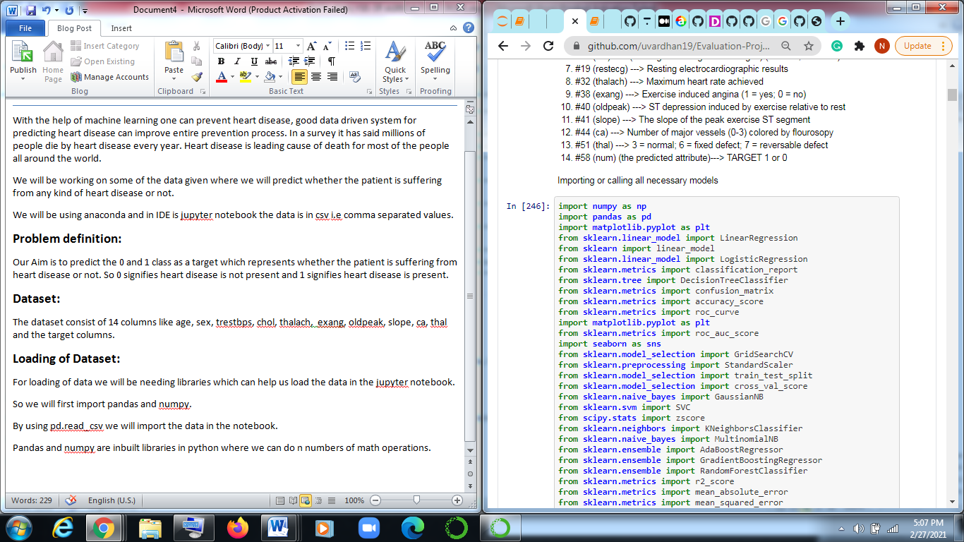

Here we have used numpy as np and pandas as pd, mathplotlib.pyplot as plt.

So now we will be calling our dataset.

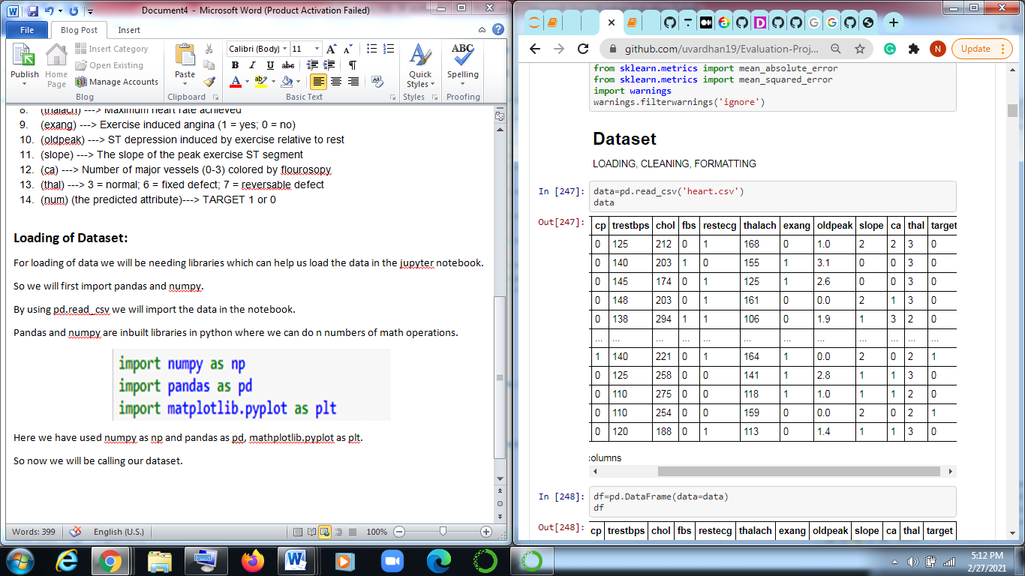

We have saved our data set in variable called df so we have wrote **df=pd.read_csc(“Heart.csv”).**

**Checking shape.**

Checking the shape means we will be checking numbers of columns and rows in the entire data.

We will call it as follow.

**df.shape**

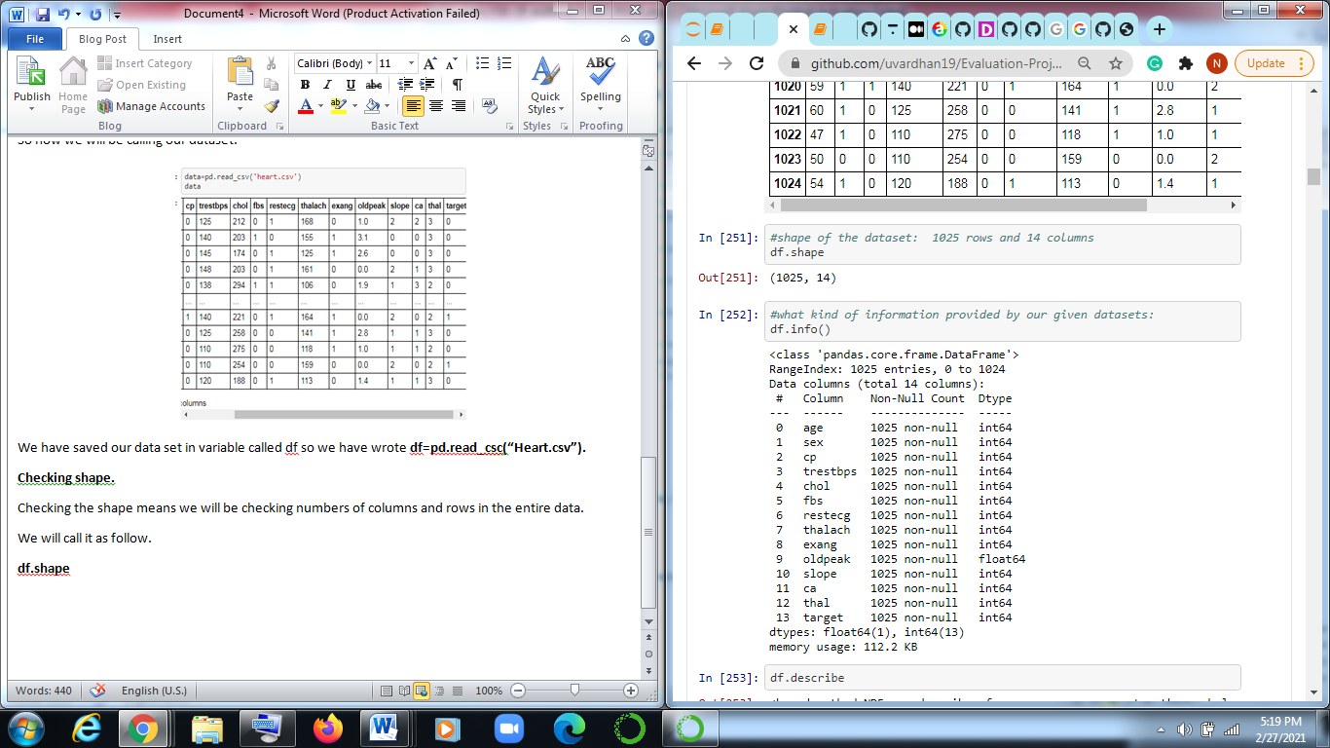

As we can see there are 1025 rows and 14 columns.

Now we will use info function to see info of all the data in which we will get all the info of all columns.

df.info is code we will run.

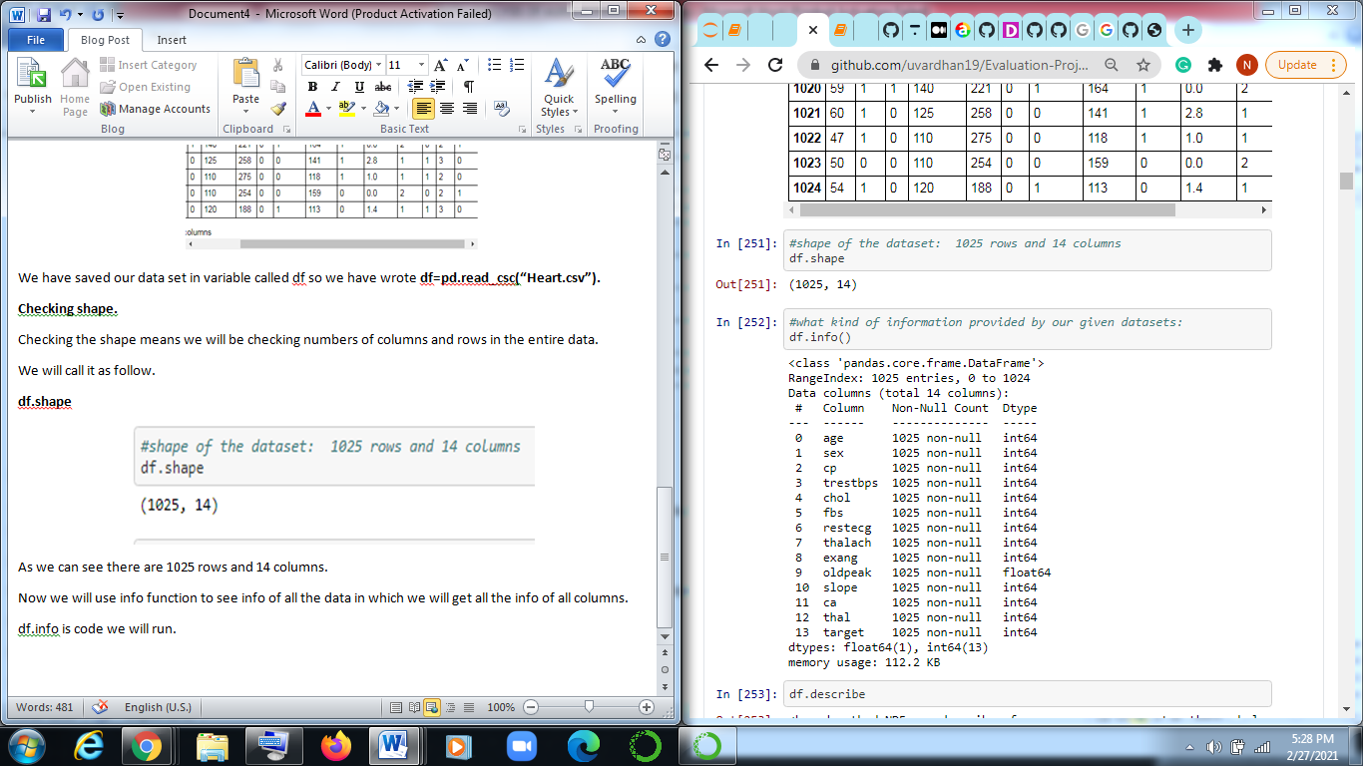

Now we use describe function where we will get information about Mean, standard deviation , minimum , maximum, 25% ,50%,75%,max.

Code: **df.describe()**

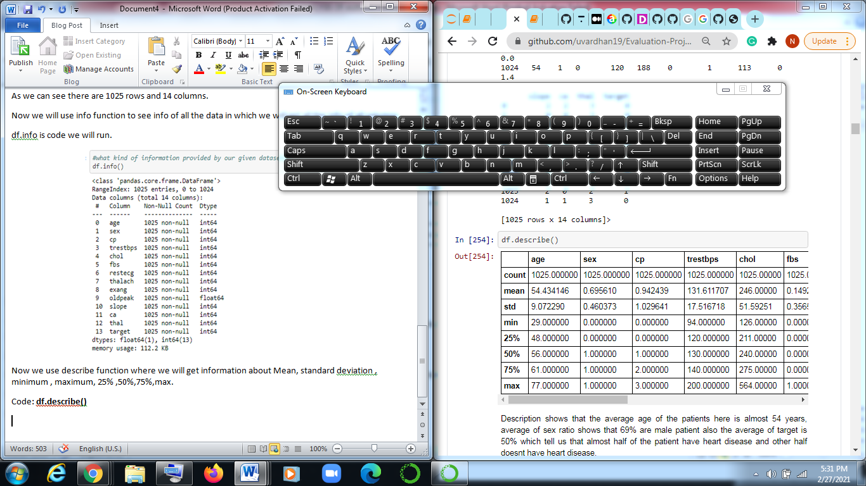

Description shows that the average age of the patients here is almost 54 years, average of sex ratio shows that 69% are male patient also the average of target is 50% which tell us that almost half of the patient have heart disease and other half doesn’t have heart disease.

On the other hand we can see the min and maximum values of each variable, such as min age is 29 years and max is 77. Through this describe we can analyse other fields also.

Now we will be checking data type of all attributes.

Code: **df.dtypes**

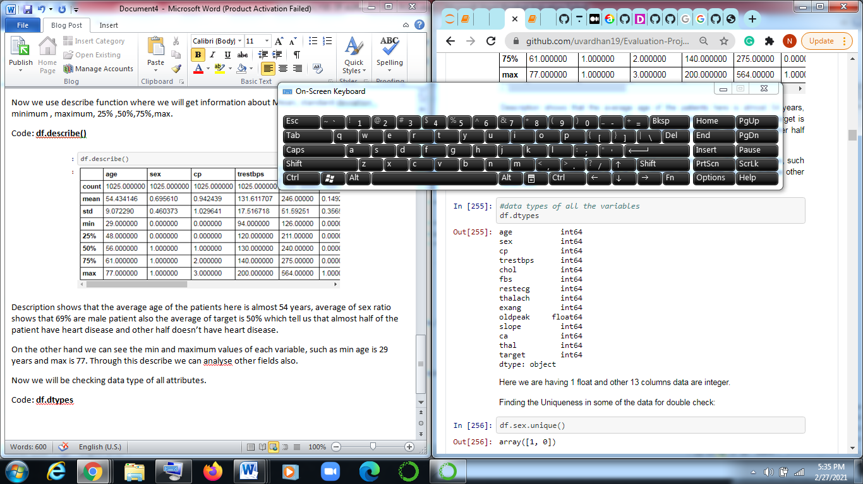

Here we are having 1 float and other 13 columns data are integer.

**Checking for uniqueness**

Finding the Uniqueness in some of the data for double check**:**

Uniqueness is checking for unique values of all variables.

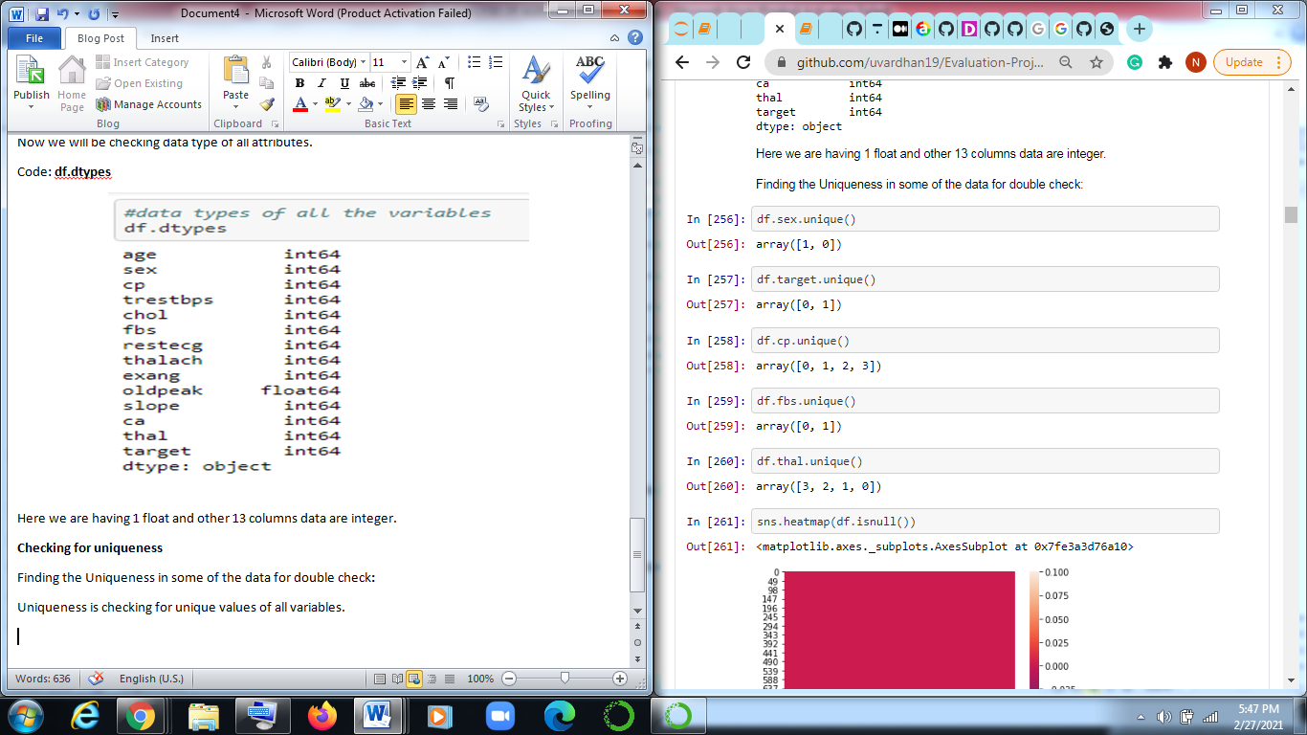

Code : **df.sex.unique()** which shows there are 2 variables 0 (female) and 1(male). Similarly for target there are two values in the columns, for cp also there are 4 unique values in the columns, fbs contains 2 values., thal contains 4 values.

**Checking for null values**

It is very important to check null values as missing data may vary the results of the prediction, so it is very important to handle the null values, we can check it by using inbuilt df.isnull().sum() and for visual we can use seaborn library where heatmap is used to check the null in visual format.

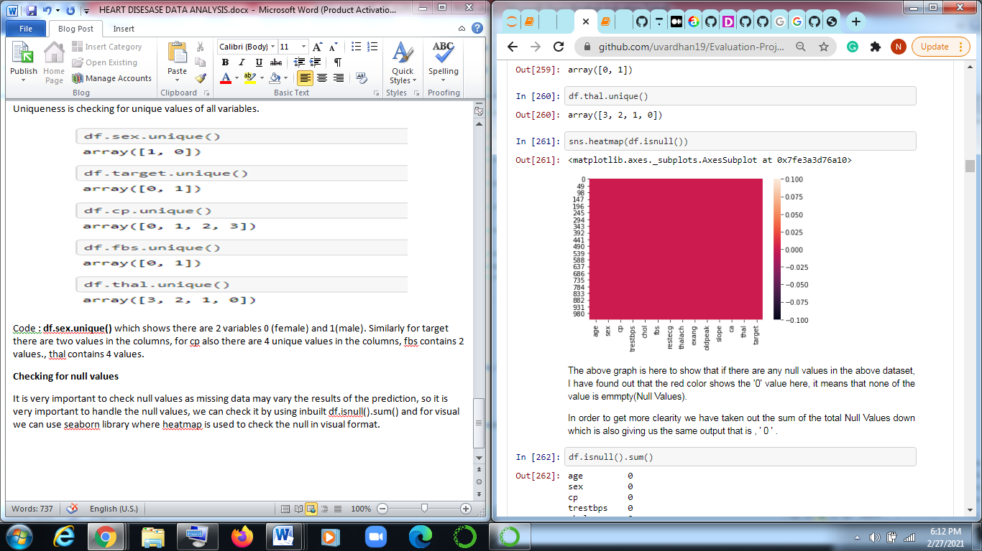

The above graph is here to show that if there are any null values in the above dataset, I have found out that the red color shows the '0' value here, it means that none of the value is empty(Null Values).

In order to get more clearity we have taken out the sum of the total Null Values down which is also giving us the same output that is , ' 0 '.

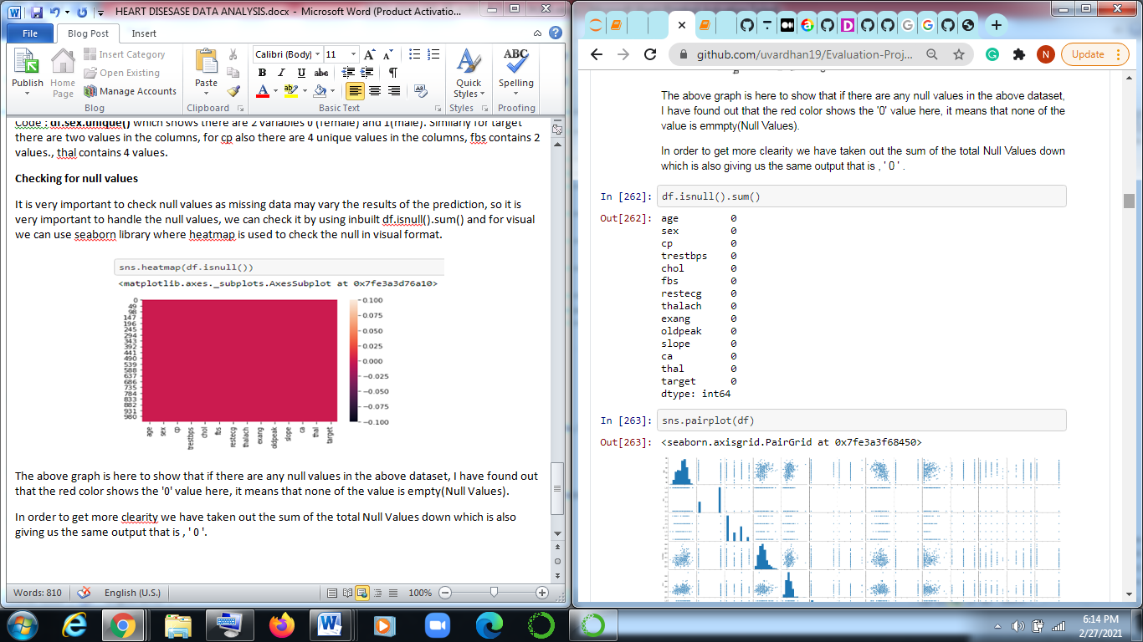

Now we will be using seaborn function to pairplot of various attributes with each other.

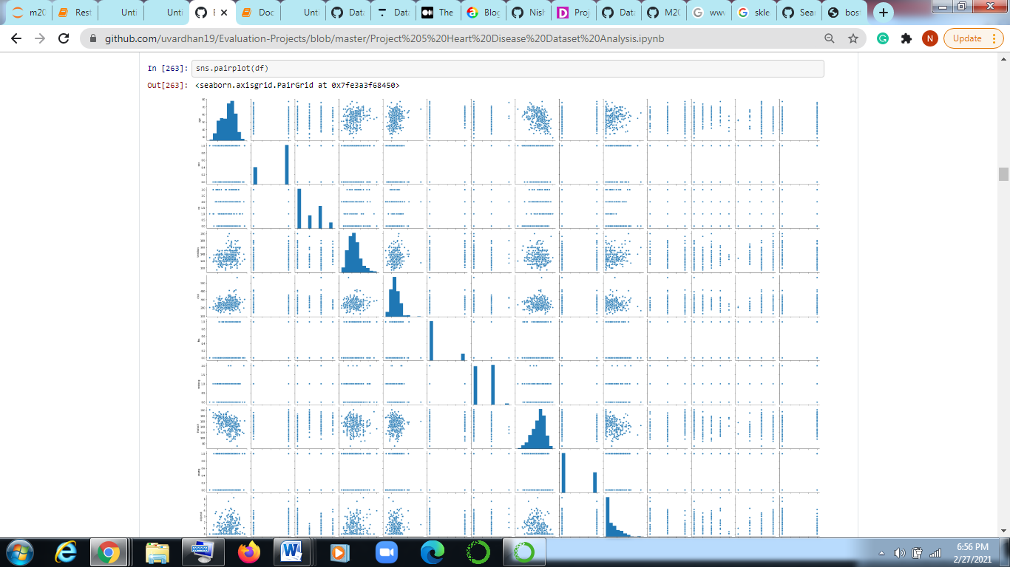

Pairplot has been constucted above to show or allow us the see both the distribution of each variables and also to show the relationship between each of the two variables, "/" -->shows the positive corelation where as "\" -->shows negative corelation for some there are holizontal lines which shows neutral relationship with each other.

Through the above and below graph we have come accros to the attributes or the fields which are positively corelated or neutral corelated to each other, Hence we would be taking them in to the consideration.

These fields are :

'age','sex','cp',

'trestbps','chol','fbs',

'restecg','ca','thal',

'target'

These fields are some what showing positive or neutral correlation with each other.

**Checking correlation.**

The below graph shows is the stucture of corelation between each of the variables with respect to the heatmap.The black dots represent negative corelation where as off white color shows the positive corelation.

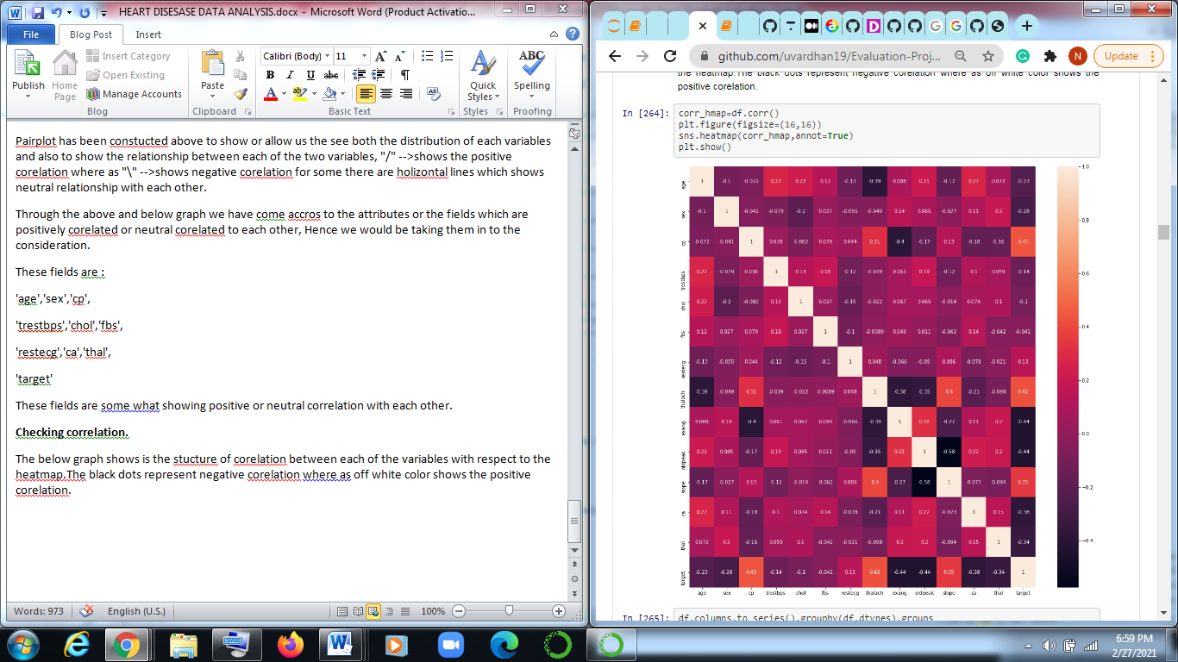

Now we will plot histogram of various attributes.

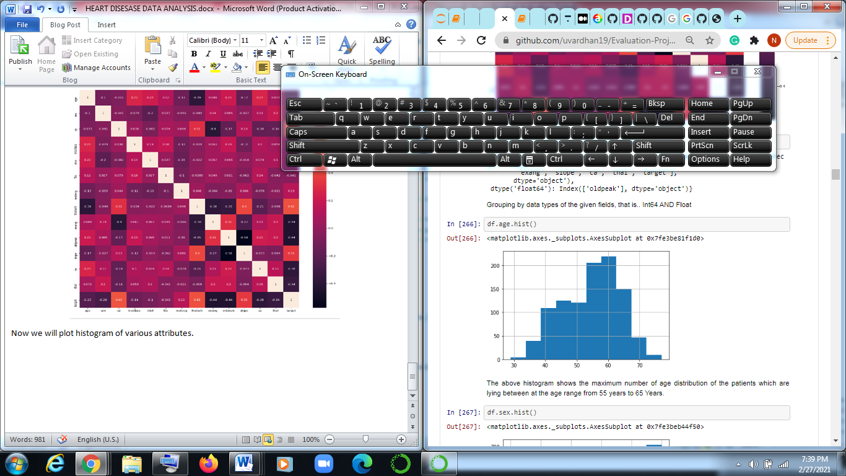

The above histogram shows the maximum number of age distribution of the patients which are lying between at the age range from 55 years to 65 Years.

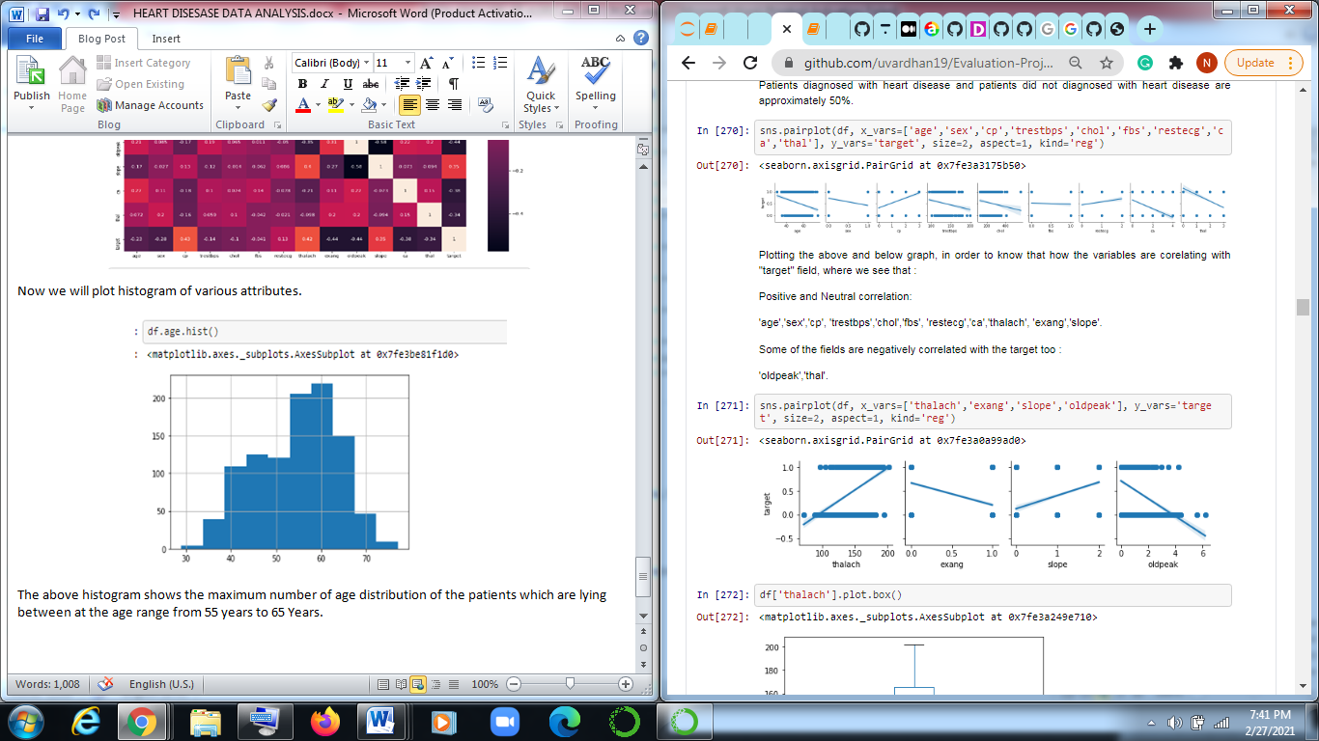

Plotting the above and below graph, in order to know that how the variables are corelating with "target" field, where we see that :

Positive and Neutral correlation:

'age','sex','cp', 'trestbps','chol','fbs', 'restecg','ca','thalach', 'exang','slope'.

Some of the fields are negatively correlated with the target too :

'oldpeak','thal'.

**Checking for outliers:**

For outliers we have to plot boxplot where we can see whether they are present or not.

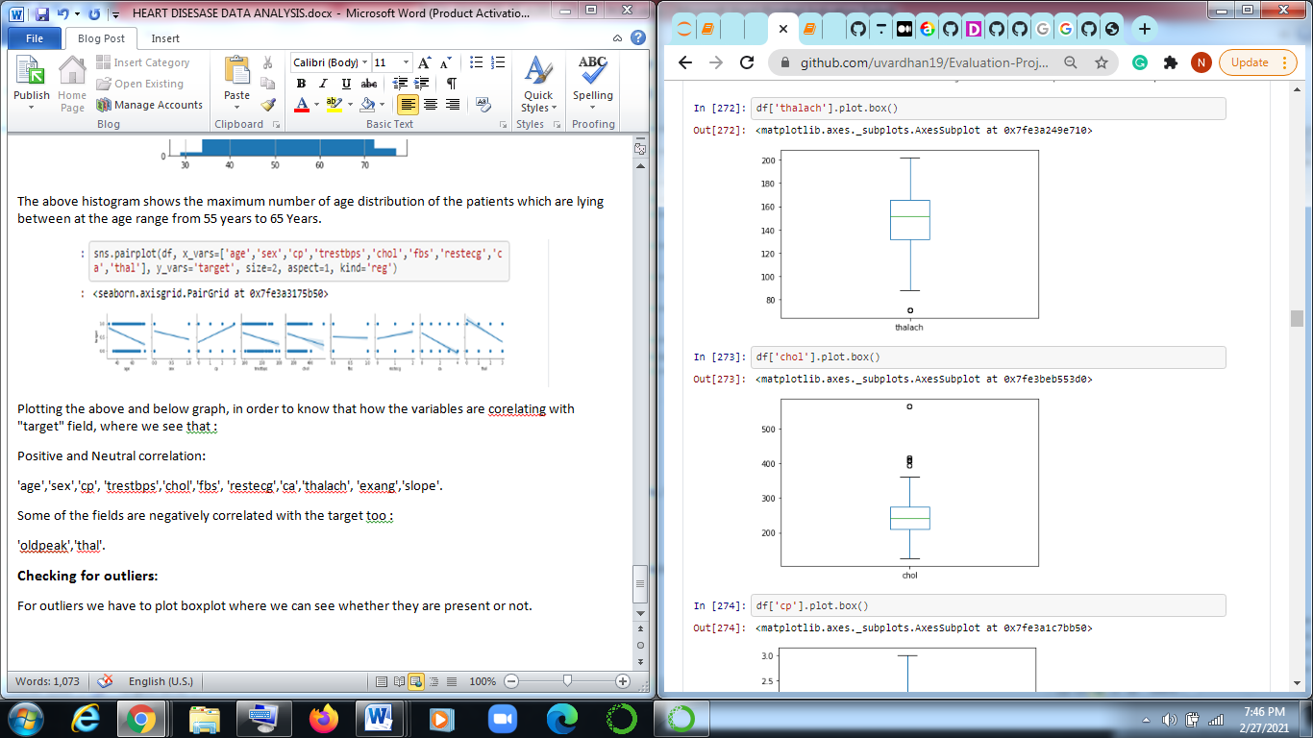

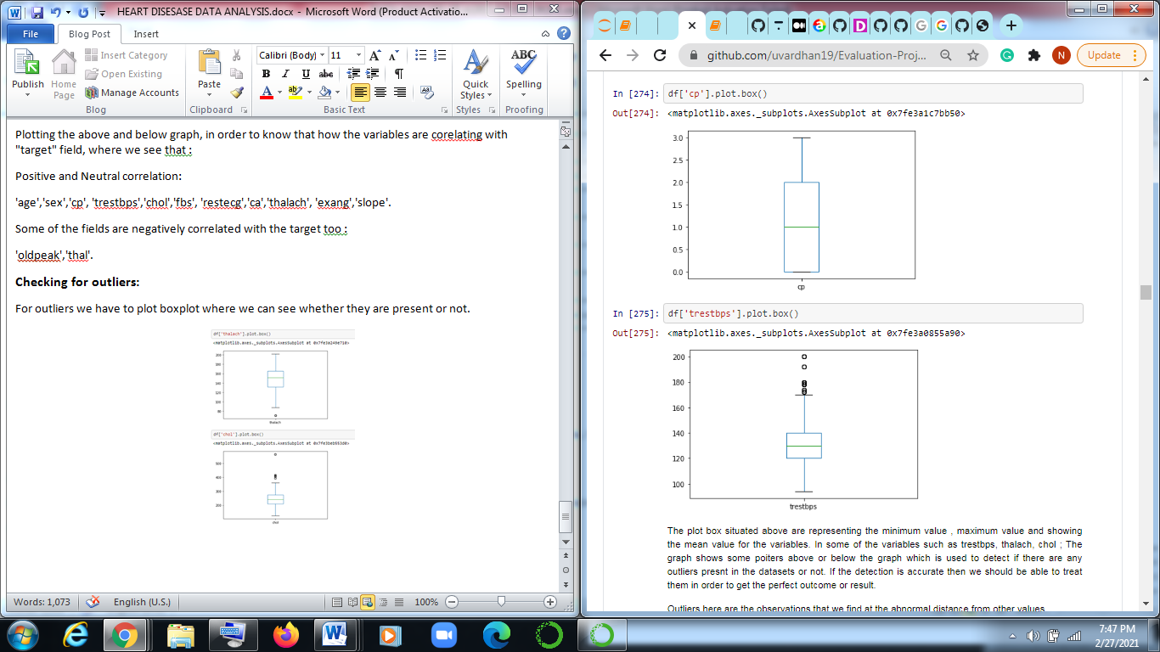

The plot box situated above are representing the minimum value , maximum value and showing the mean value for the variables. In some of the variables such as trestbps, thalach, chol . The graph shows some pointers above or below the graph which is used to represent if there are any outliers present in the datasets or not. If the detection is accurate then we should be able to treat them in order to get the perfect outcome or result.

Outliers here are the observations that we find at the abnormal distance from other values.

We are going to use z score:

Removing outliers:

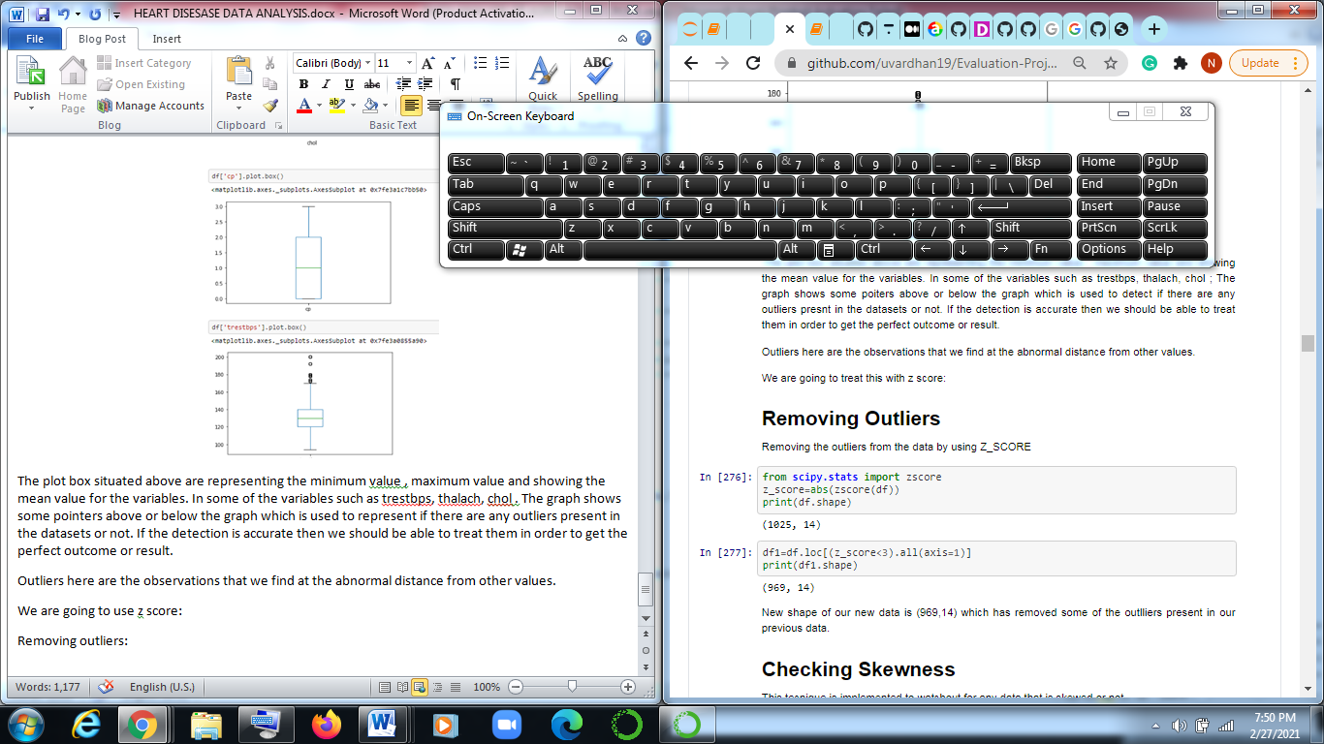

We have imported zscore from scipy.stats and the we have filled the data in the zscore.

For expecting the values there is a certain range or threshold we have to mention the threshold is 3 so all the values beyond 3 will be outliers or will be dropped. As we can see the code df.loc([z_score<3).all(axis=12)) where axis =1 means for all columns.

After printing the shape we can see there in reduction numbers of rows 1025 is reduced by 969 by removing outliers.

New shape of our new data is (969,14) which has removed some of the outlliers present in our previous data.

**Similarly checking for skewness:**

This we use to see whether any data is highly skewed or not.

**df.skew()**

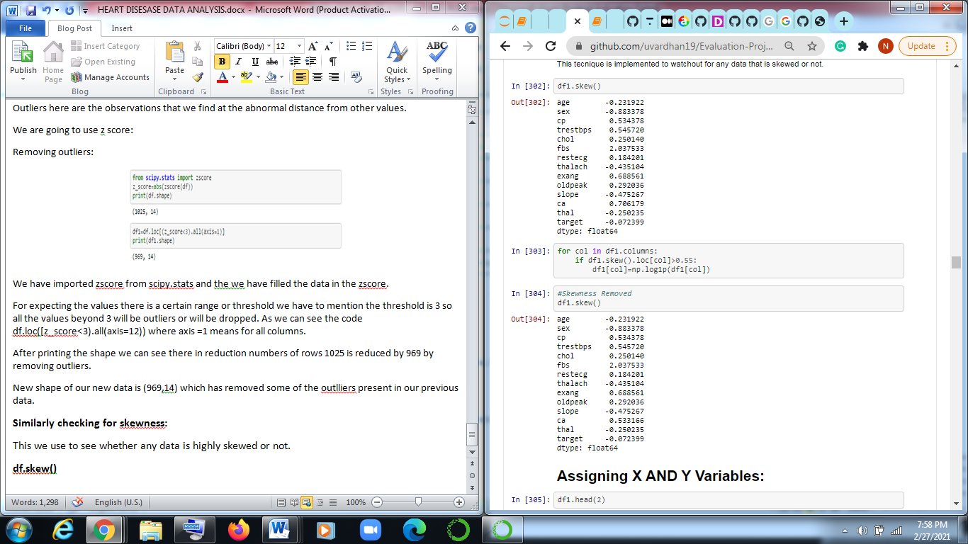

In the first cell we have checked df.skew().

Next step we defined a for loop in which we have called a variable called col from df.columns.

We gave a condition df1.skew().loc[col]>0.55:

So by log transform we have removed the skewness.

And we again check for df.skew() we cannot completely remove skewness but we can reduce it to some extened.

**Model Making and model selection.**

First we have to assign the values which means we will be making data ready for training and testing, here we will take two variables x and y in y we will assign target attribute and in x we will assign remaining attributes.

We also need to check for shape of x and y variable.

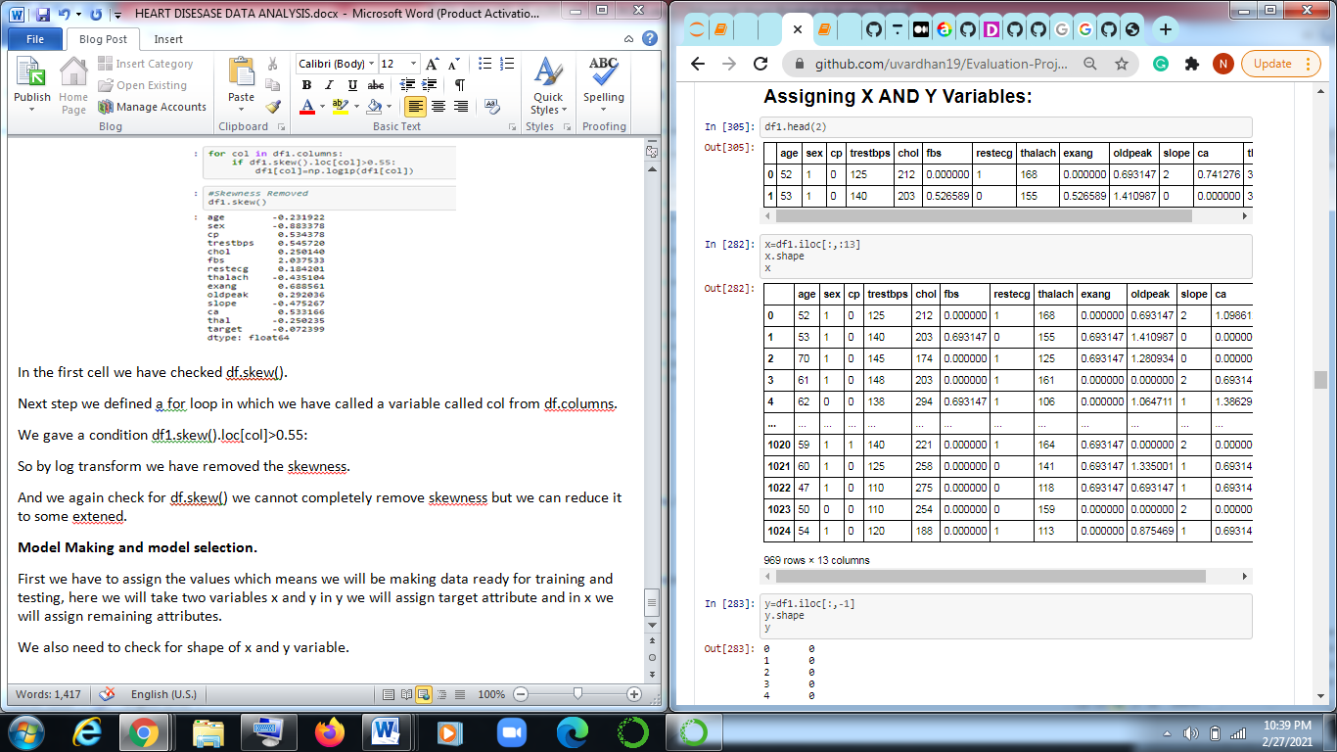

**Model selection:**

We have to use various types of models to get optimal solution.

We have to import all other required libraries.

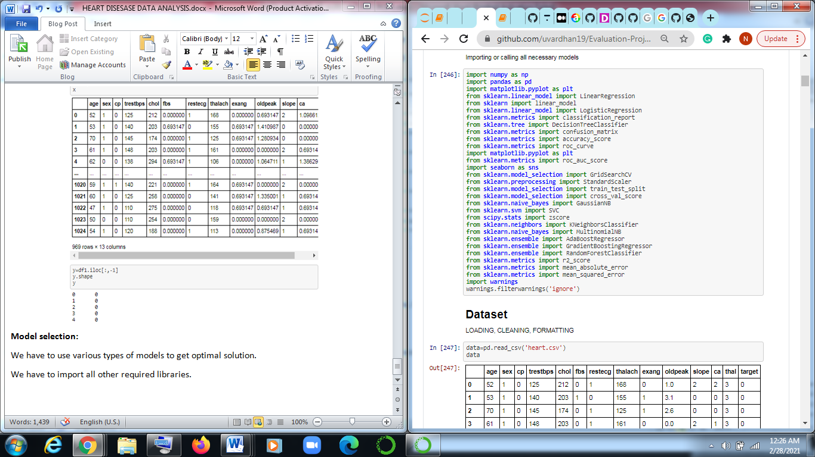

As the required target is 0 and 1 we will use Logistic Regression, Decision tree classifier,and all others models we will check the best optimized models.

The target variable is 0 and 1 they are classified in Logistic so in this type we use accuracy_score, Classification_report, Confusion matrix and Roc curve and AUC curve.

Now we will be using train test split which is in built in sklearn.model_selection.

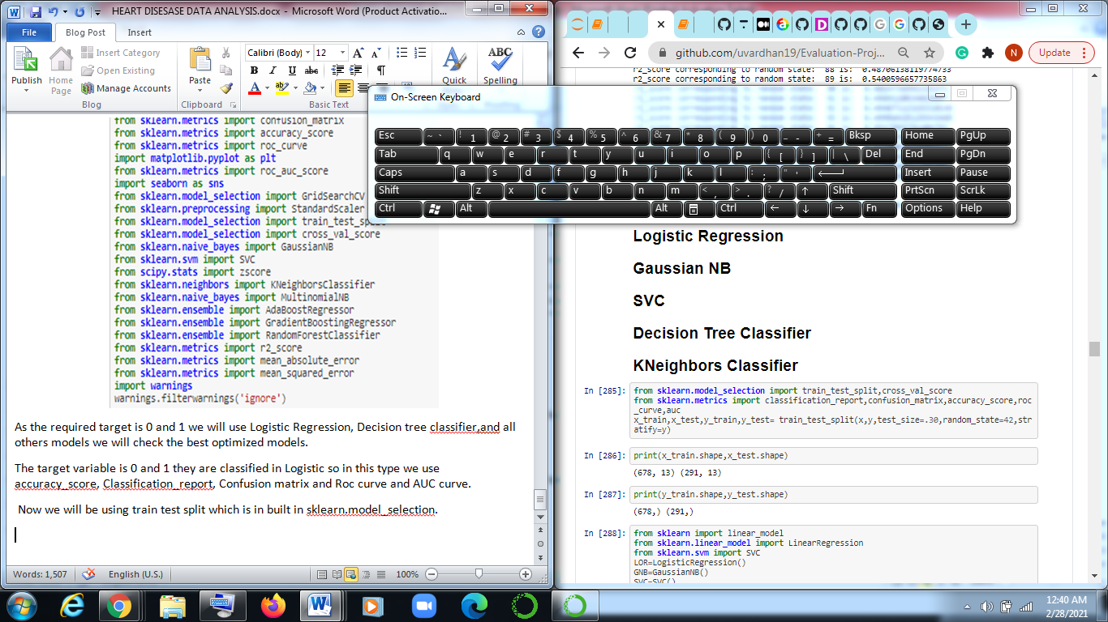

In test size we decide how much data we will be sending for testing in this we are assigning 30% of data for testing.

Print the shape of the test so x train has (678,13) and x_test has (291,13) and y_test and y_train has 291 and 1 column and (678,1).

Now we will define all the models and save them in variables.

LOR=LogisticRegression()

GNB=GaussianNB()

SVC=SVC()

DTC=DecisionTreeClassifier(random_state=10)

KNN=KNeighborsClassifier()

Next we will be creating a list of models and every models gets appended and stored in models list as below.

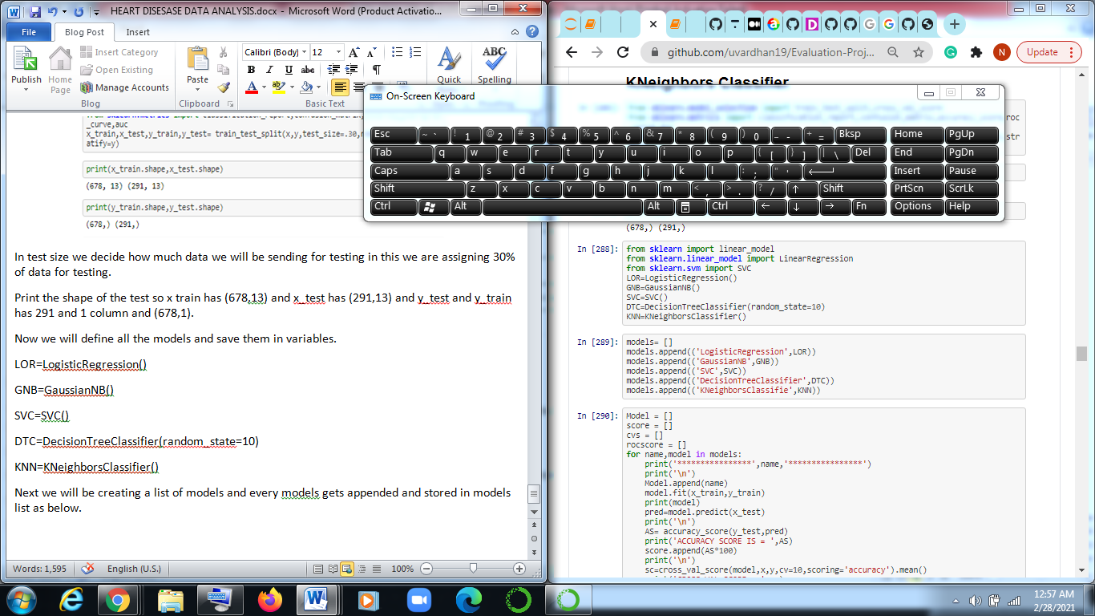

Now we will create a empty list of model and score and csv, roc score.

Create a for loop where we will run each model one by one and get the required result.

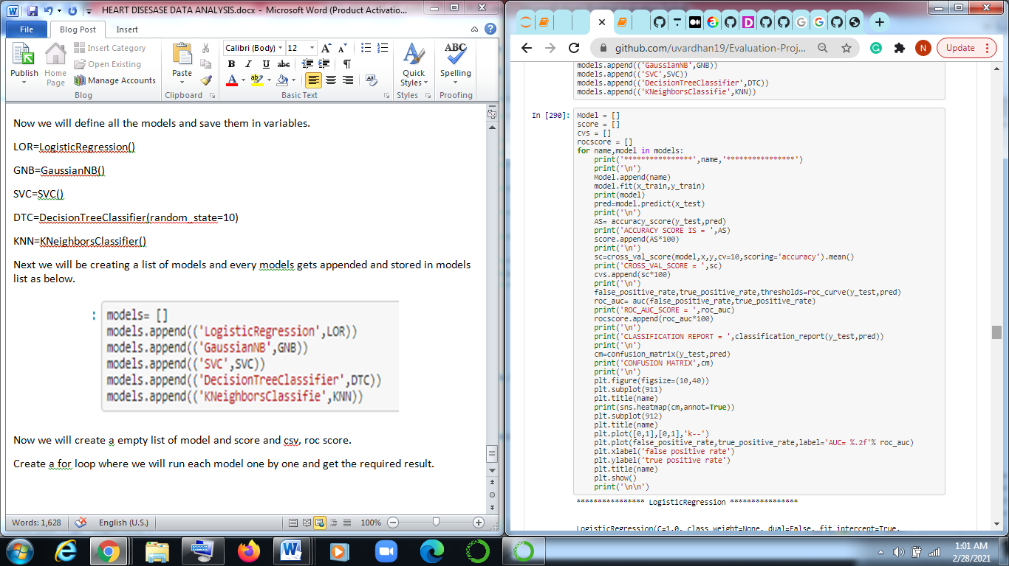

In the above code we have created a empty list first where for each model is send to test and train where we will fit the model and we will predict x_test where model will predict values for x_test.

Now we will predict the accuracy score so code is **accuracy_score(y_test,pred)**

Cross validation is also necessary to distribute data for testing and training.

We will also be plot confusion Matrix and classification Report where we will come to how much data is accurate and what number of data is error. classification consist of true positive Rate and false positive rate this terms will be used for plotting AUC and ROC curve where area under curve tells the model working.

With the help of append operation we will append the list with other models.

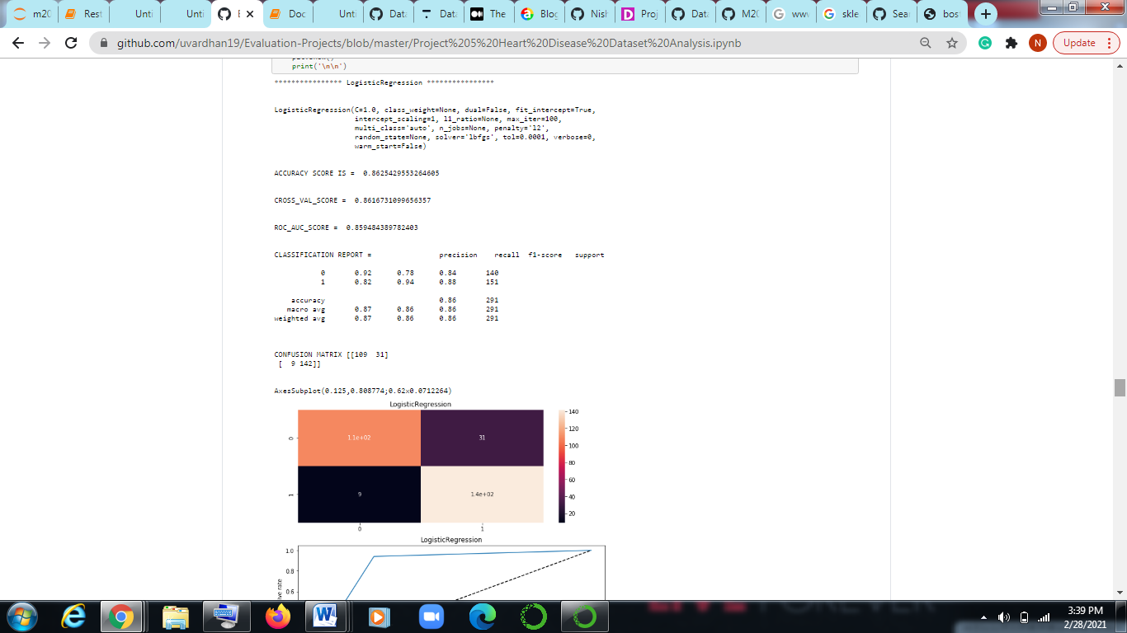

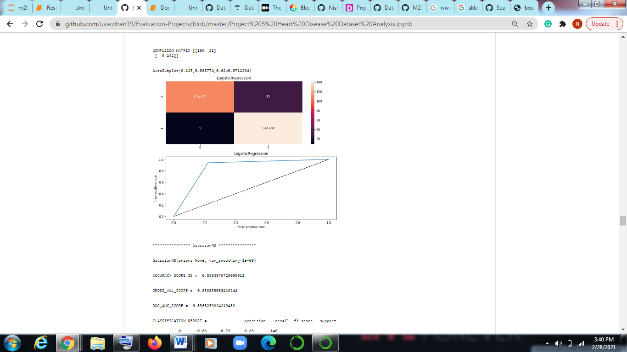

The accuracy score of 86% so model is working fair enough.

Cross validation score is also good.

Confusion matrix 31 and 9 are the false positive rate.

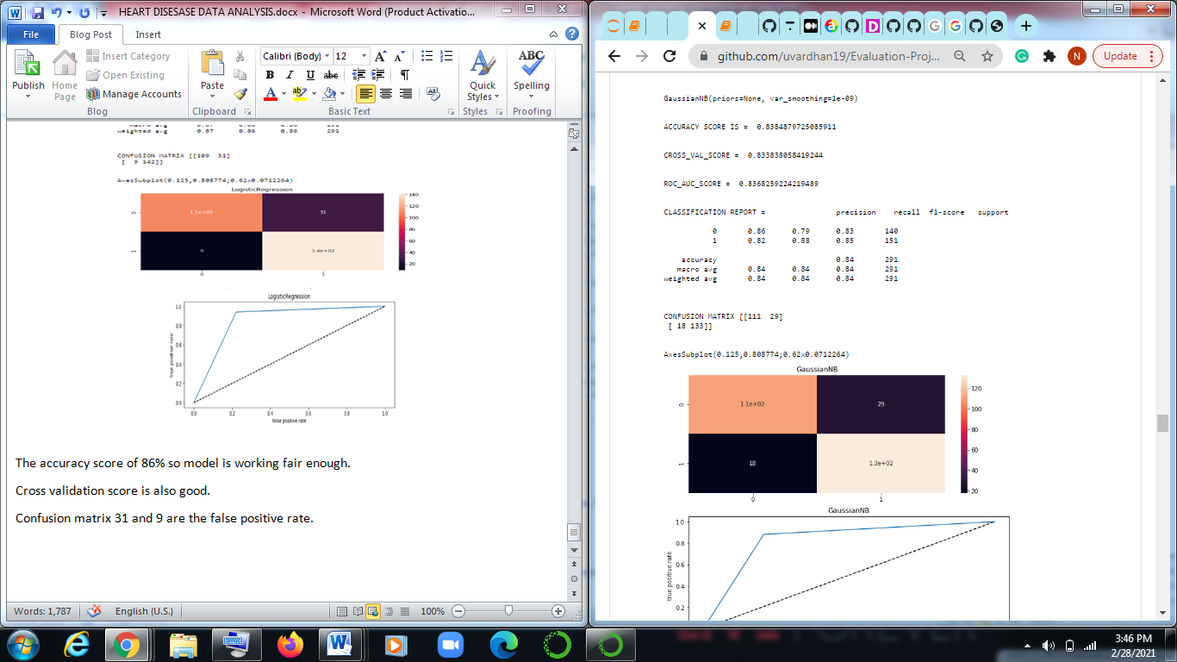

The accuracy score of 83% so model is working fair enough.

Cross validation score is also good.

Confusion matrix 29 and 18 are the false positive rate

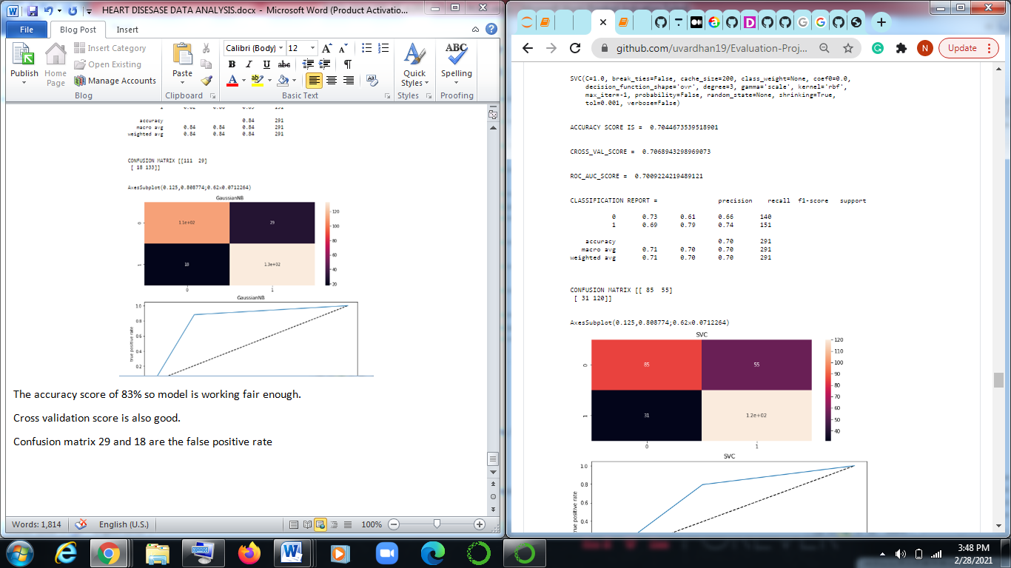

The accuracy score of 78% so model is working not that good as compare to logistic and Gaussian NB.

Cross validation score is also good.

Confusion matrix 55 and 31 are the false positive rate

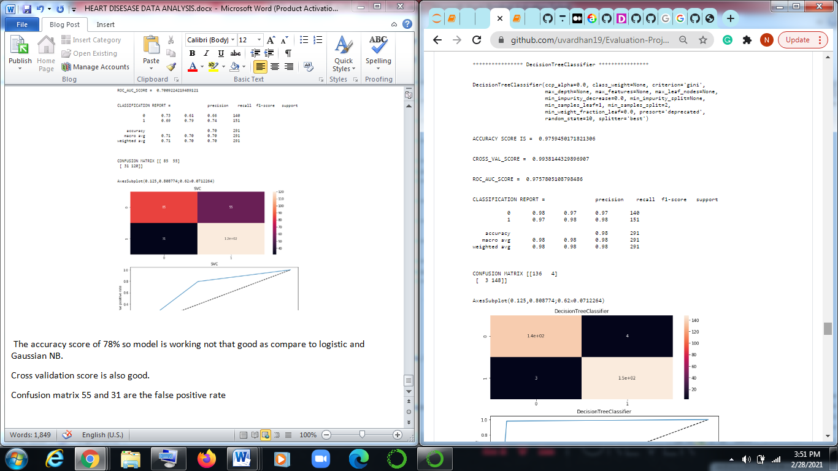

Accuracy score is 97 % which is the best than rest of.

Now we will plot the result of all the models in data frame.

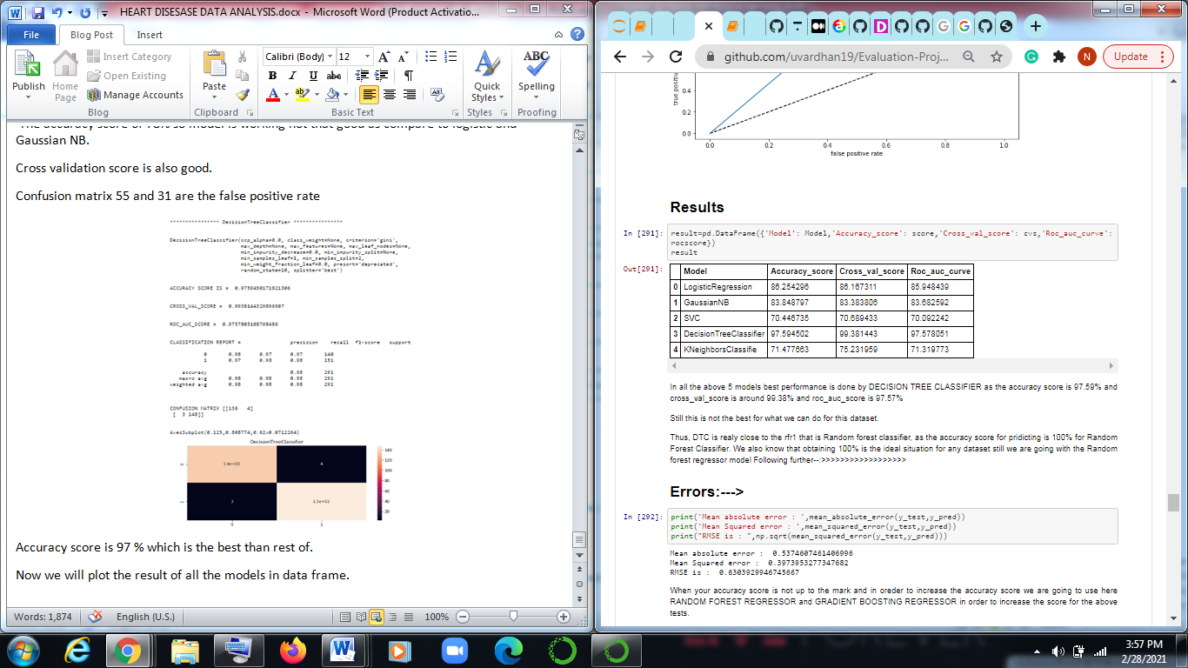

In all the above 5 models best performance is done by DECISION TREE CLASSIFIER as the accuracy score is 97.59% and cross_val_score is around 99.38% and roc_auc_score is 97.57%

Still this is not the best for what we can do for this dataset.

Thus, DTC is really close to the rfr1 that is Random forest classifier, as the accuracy score for pridicting is 100% for Random Forest Classifier. We also know that obtaining 100% is the ideal situation for any dataset still we are going with the Random forest regressor model

Now we will find the error in the Decision tree classifier.

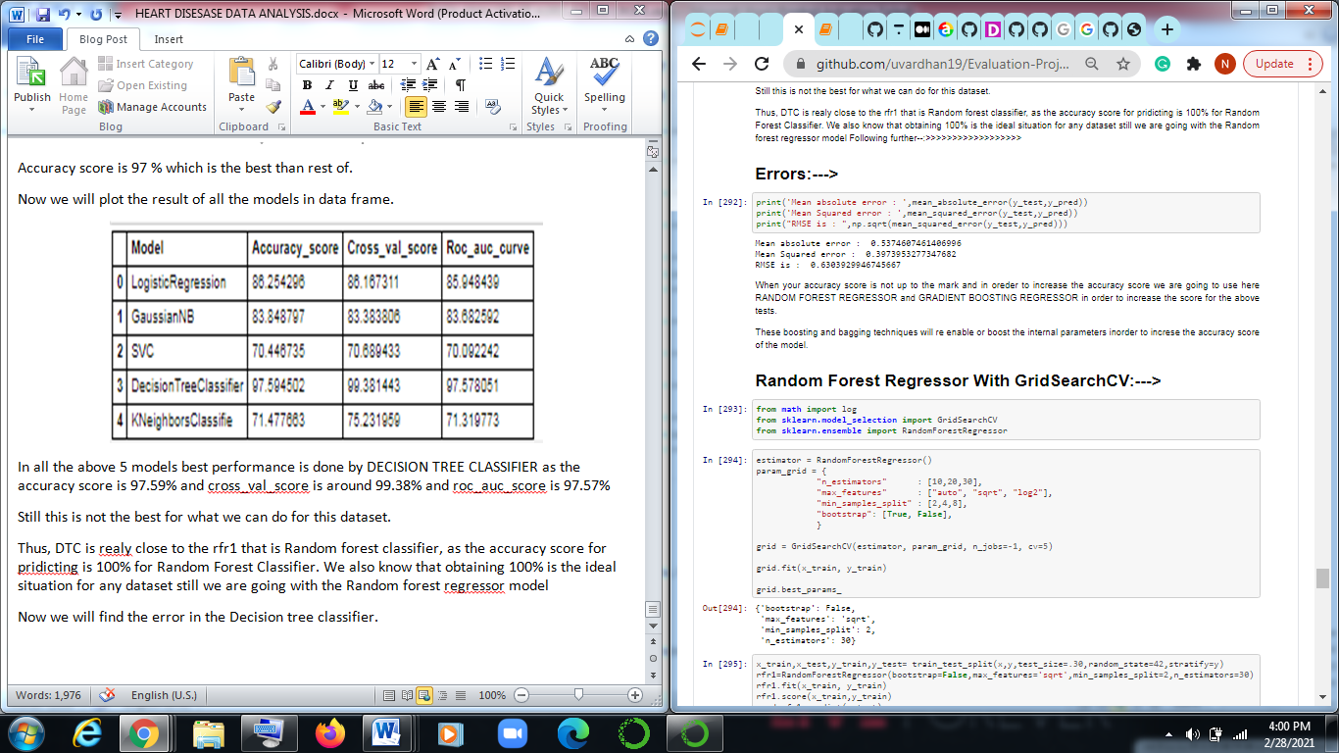

When your accuracy score is not up to the mark and in oreder to increase the accuracy score we are going to use here RANDOM FOREST REGRESSOR and GRADIENT BOOSTING REGRESSOR in order to increase the score for the above tests.

These boosting and bagging techniques will re enable or boost the internal parameters inorder to increse the accuracy score of the model.

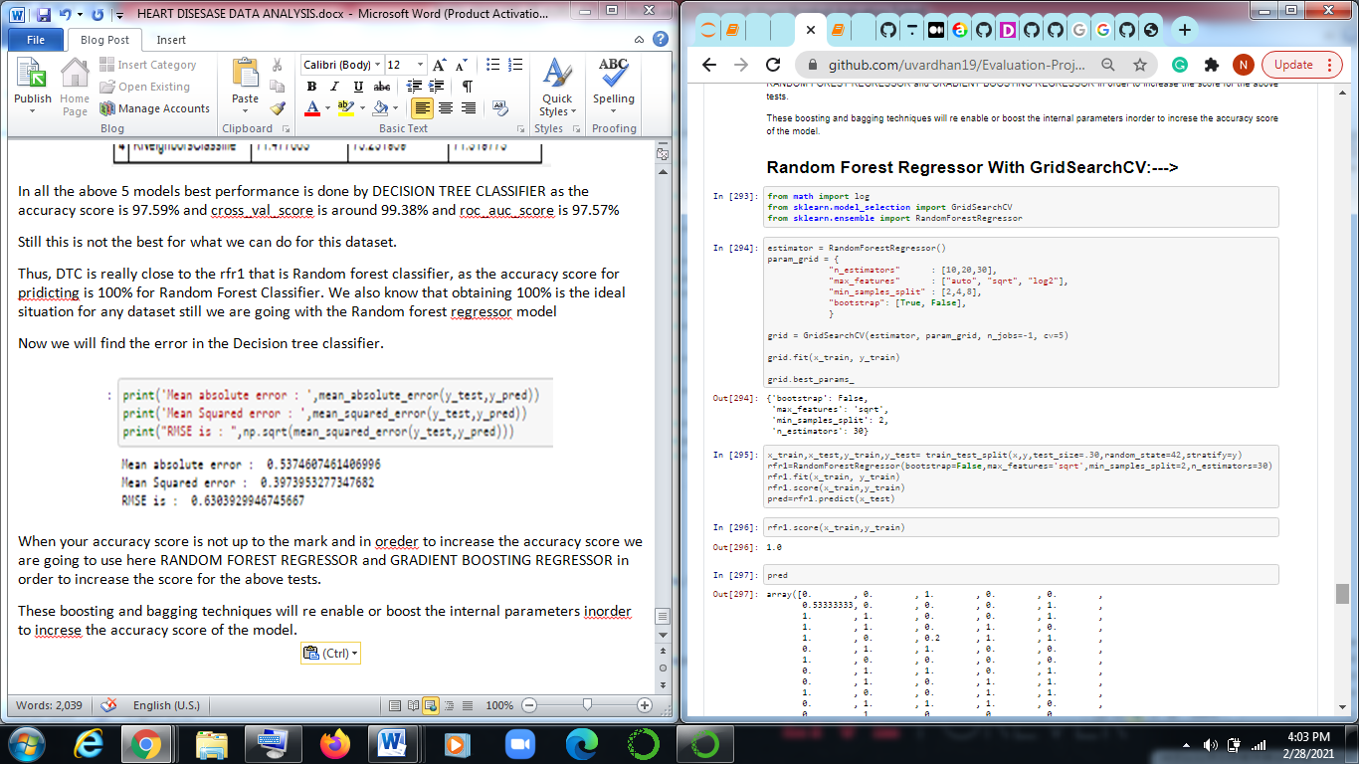

This is because the accuracy score is the highest which is above 99% approx to 100% which is higher than any other model which have been tried above or below. Decision Tree Classifier is the only model which is near to the Random Forest Classifier model.

The below score is going to predict our target and helps in determining the patients on which aspects patients will be diagnosed with the heard disease or not. With this result we can actually going to predict the heart disease in the patients which will be very helpfull to the patients and doctors can also start the treatment before.

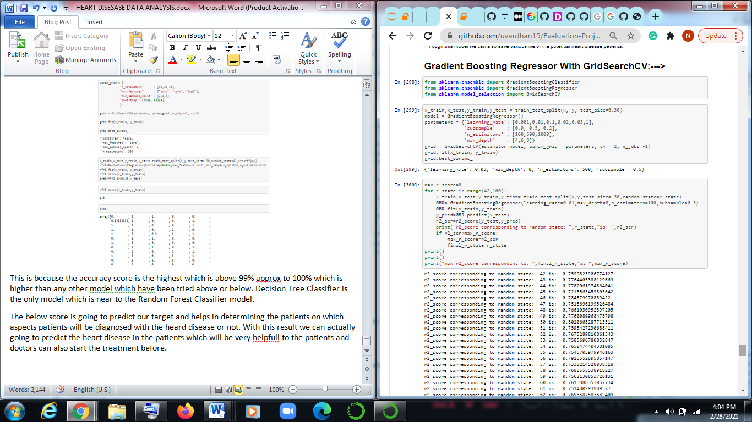

Max r2 score is 50 is 0.802066.

Now we will save the model using job lib for that we have to import joblib

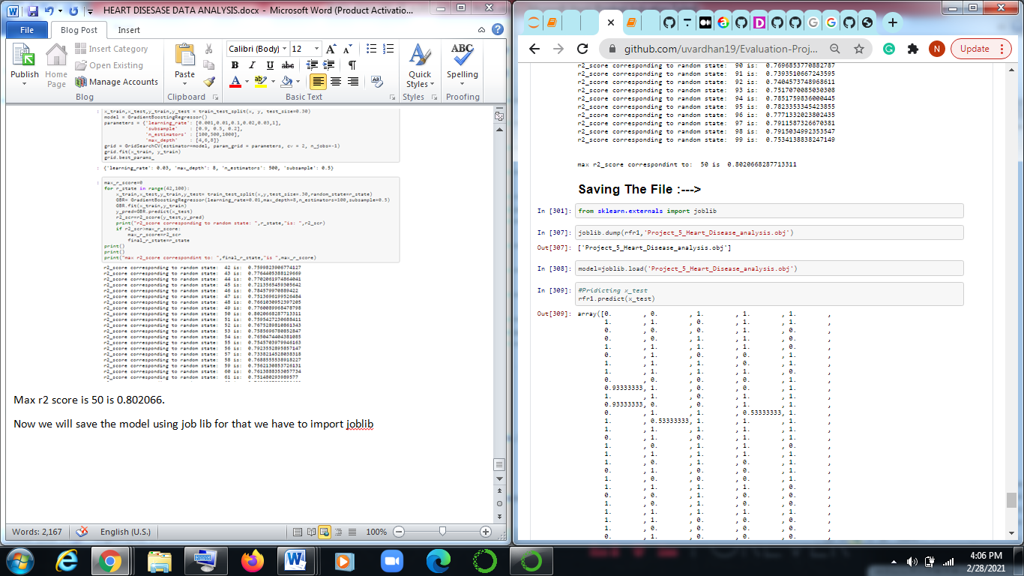

This is how we Analysis the data and make model ready for machine learning.

For more info you can visit datatrained.com.